3. Data Flow & System Behavior
• DFD (Data Flow Diagram) – Context-level and detailed levels showing how data moves through the system.

Data flow (level 0)

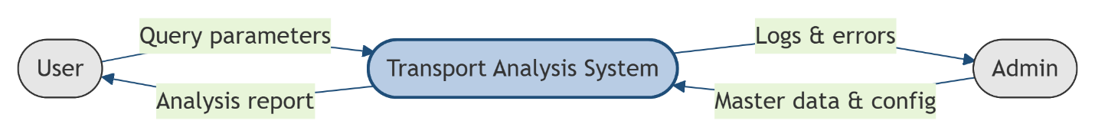

Data flow (level 1)

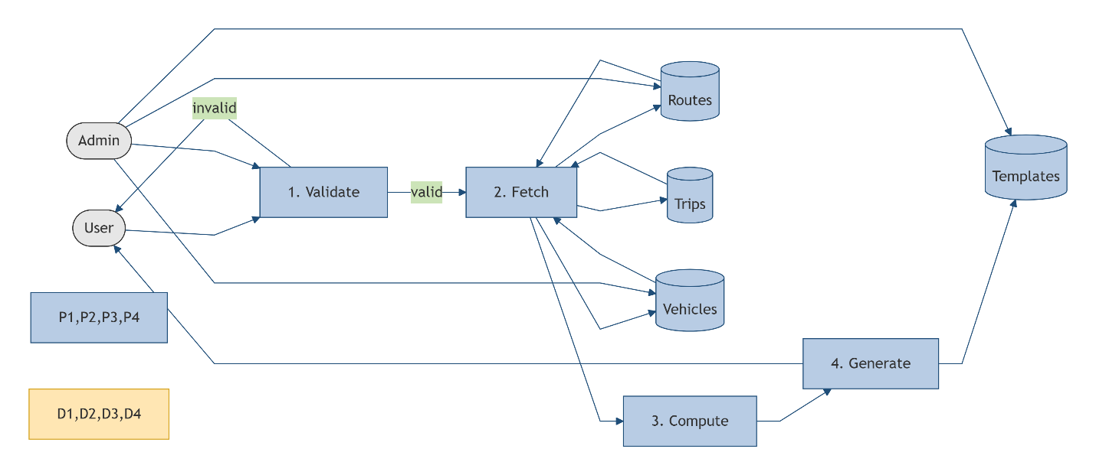

• Sequence Diagrams – Process flow representation of key interactions between components.

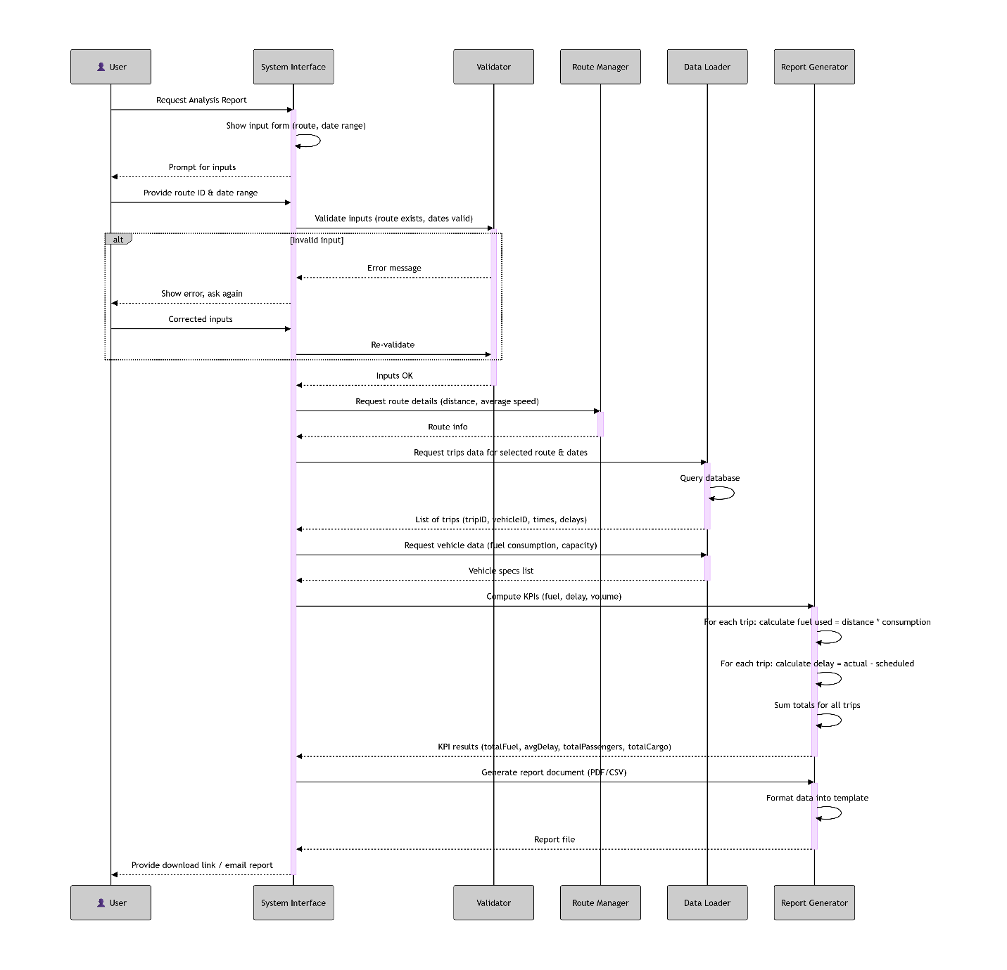

• Class Diagram – Defines the structure of the system by showing classes, attributes, methods, and relationships.
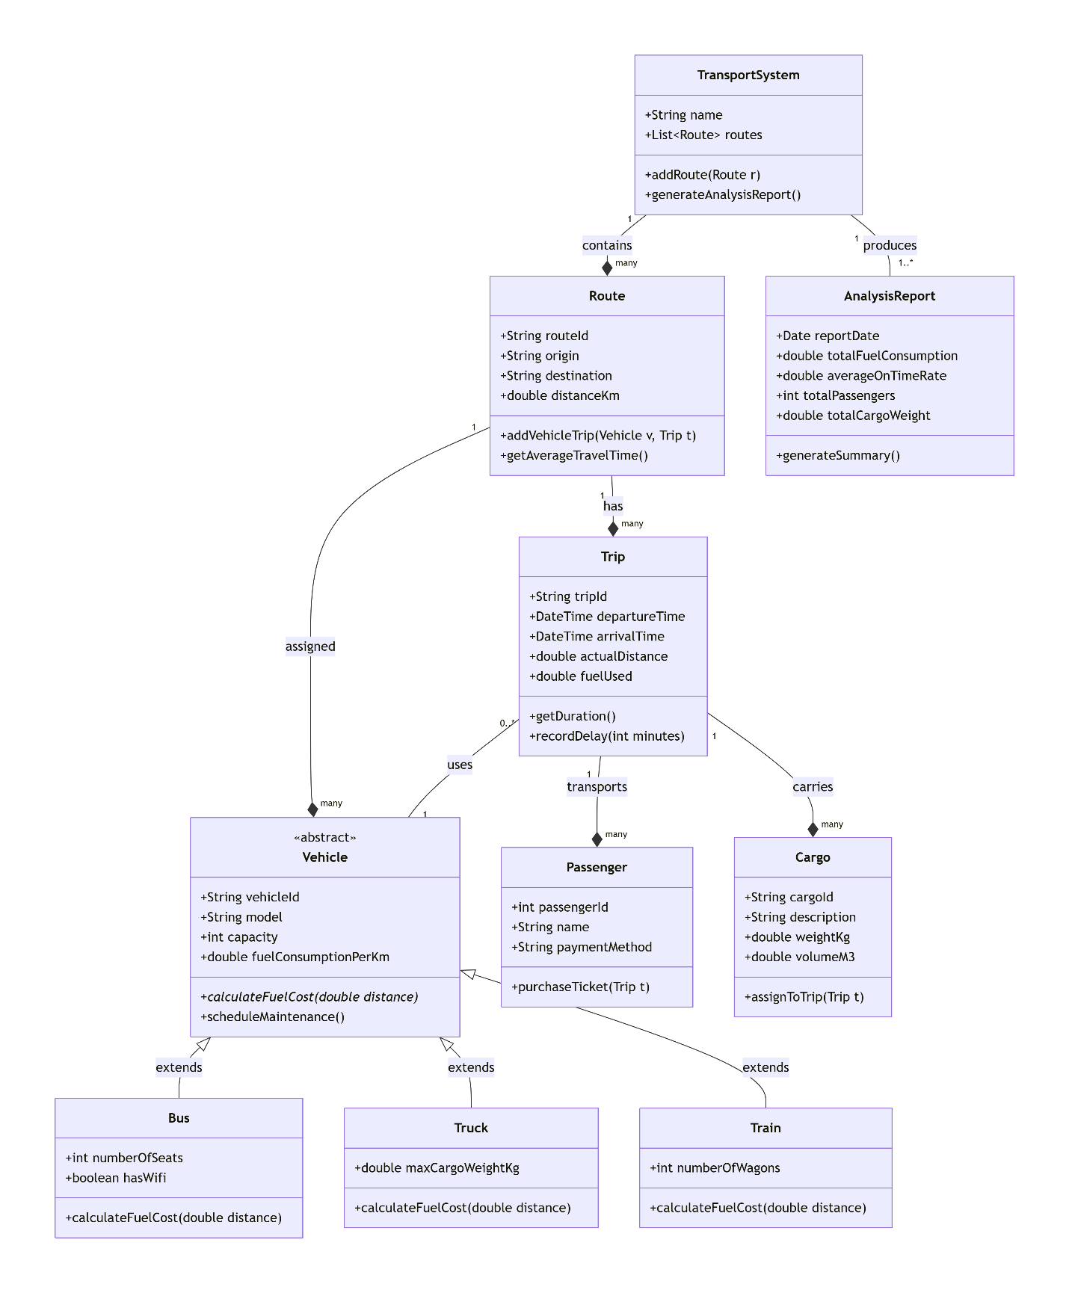
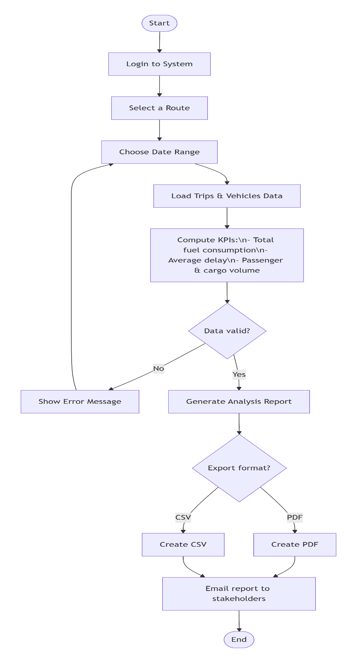
• Activity Diagram – Visualizing the workflow of processes or user actions within the system.

• State Diagram – Represents different states of an object and how it transitions between them.
